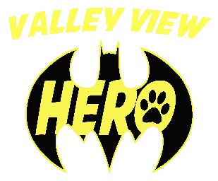
Valley View students do INCREDIBLE work to make our community a better place.

My name is ___________________________________ and I am in _________ grade.
(first and last name)
My teacher is _____________________________________________.

This is a picture that shows me helping my community. I am proud of my great work!
This is a description of what I did and an explanation of how this makes me a responsible, caring member of our community:
__________________________________________________________________
__________________________________________________________________
__________________________________________________________________
__________________________________________________________________
__________________________________________________________________
Parent/Guardian signature:__________________________________________

As a way to expand the Valley View HERO program, we have incorporated a community service section to the Jaguar Way. To reach the Jaguar level, students will need to complete a Paw Pride form in addition to earning 100 additional HERO tickets. THIS FORM IS TO ENCOURAGE BEING A HERO IN THE COMMUNITY. It can be filled out at any time and does not have to be only when the student is ready for the Jaguar club. The forms are available on the website under The Valley View Jaguar Way section- Jaguar Way at home. The forms are also available from your child’s teacher or in the Valley View school office.
The Paw Pride form should be SOMETHING ABOVE AND BEYOND REGULAR HOUSEHOLD CHORES. Below are some suggestions but it can be anything involving the community.
Here are some suggestions…
Shoveling, somewhere other than at home (ex: for elderly neighbors, or in the community)
Boy Scout or Girl Scout activities
Charity work
Goodwill
Volunteering
Helping neighbors, or in the community
Church events

If you have any questions or concerns, feel free to contact your child’s teacher.

